Limitations of Using KIND for Private Cloud Networking Simulation
While Kubernetes in Docker (KIND) is effective for simulating Kubernetes clusters and application workloads, it is not designed to accurately replicate data center networking architecture.

1.1 Absence of Network Infrastructure Components
KIND does not model physical networking elements such as:
- Top-of-Rack (ToR) switches
- Spine switches
- Core routing layers
All communication occurs through:
- Docker bridge networks
- Kubernetes CNI plugins
As a result, the structural hierarchy of a leaf–spine topology is not represented.

1.2 Lack of Underlay Network Modeling
In real private cloud environments:
- The underlay network handles physical routing using protocols such as BGP or OSPF
- The overlay network (VXLAN) carries workload traffic
KIND:
- Primarily operates at the overlay level
- Does not simulate underlay routing or switch-to-switch communication

1.3 No Support for Routing Protocols
KIND does not provide the ability to configure:
- BGP sessions between switches
- OSPF routing domains
- ECMP (Equal-Cost Multi-Path) behavior
Routing decisions are abstracted and handled internally by the container runtime and host OS.

1.4 Limited Network Visibility and Control
- No direct access to routing tables between infrastructure layers
- No ability to define link-level characteristics (latency, bandwidth)
- No simulation of real packet forwarding behavior across switches

1.5 Shared Host Networking Constraints
- All nodes share the same physical network interface
- No separation of traffic across racks or switches
- Network performance is dependent on host system limitations

2. Containerlab for Private Cloud Network Simulation
To address these limitations, tools such as Containerlab are used to simulate realistic network topologies.
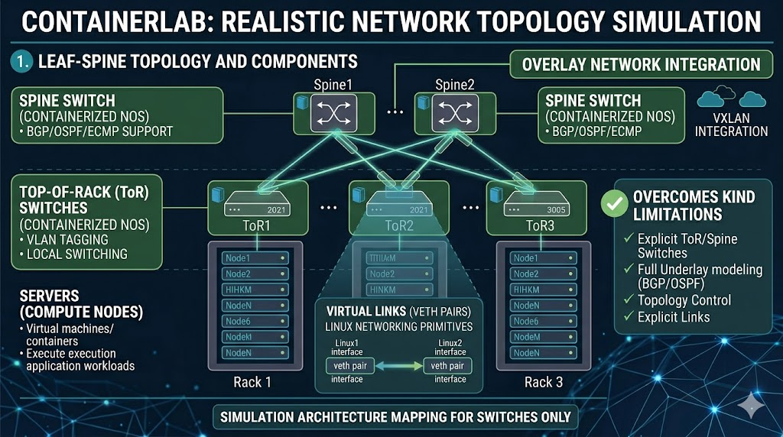

2.1 Overview of Containerlab
Containerlab is a container-based network emulation platform that allows users to:
- Define network topologies declaratively
- Instantiate routers, switches, and links as containers
- Simulate real-world data center network designs

2.2 How Containerlab Mimics Private Cloud Networking
Containerlab replicates private cloud networking by modeling both:
- Network devices (ToR and Spine switches)
- Interconnections between them

2.2.1 Emulation of Network Devices
Each network device is represented as a container running:
- A network operating system (NOS)
- Routing daemons and forwarding logic
Examples:
- Spine switch → container with routing configuration
- ToR switch → container handling rack-level traffic
These containers behave similarly to physical switches:
- Maintain routing tables
- Forward packets based on IP decisions

2.2.2 Creation of Leaf–Spine Topology
Containerlab enables the creation of structured topologies such as:
Spine1 ----- ToR1 ----- Servers
\ ToR2 ----- Servers
\---- ToR3 ----- Servers
Key characteristics:
- Each ToR connects to multiple spines
- Traffic flows through predictable paths
- Supports multi-rack simulation

2.2.3 Virtual Links and Interfaces
Connections between devices are implemented using:
- veth (virtual Ethernet pairs)
- Linux networking primitives
Each link behaves like a physical cable:
- Has interfaces on both ends
- Can carry Layer 2 or Layer 3 traffic

2.2.4 Underlay Network Simulation
Containerlab enables explicit configuration of:
- IP addressing between switches
- Routing protocols (BGP, OSPF)
- ECMP-based forwarding
This allows:
- Realistic underlay network behavior
- Dynamic route propagation

2.2.5 Overlay Integration Capability
Although Containerlab focuses on underlay:
- It can interconnect with containerized workloads
- Enables integration with overlay networks such as VXLAN

2.2.6 Traffic Flow Representation
Traffic flow in Containerlab closely resembles real data centers:
Server → ToR → Spine → ToR → Server
Each hop:
- Is explicitly defined
- Can be inspected and controlled

2.3 How Containerlab Overcomes KIND Limitations
Limitation in KIND | Containerlab Solution
No ToR/Spine switches | Simulates switches as containers
No underlay network | Full underlay modeling with routing
No routing protocols | Supports BGP, OSPF
No topology control | Declarative topology definition
Abstract networking | Explicit link-level connections

2.4 Advantages of Containerlab in Networking Simulation
- Accurate representation of data center topology
- Fine-grained control over network behavior
- Ability to test routing protocols and failures
- Reproducible and scalable configurations
- Lightweight compared to VM-based simulations

3. Conclusion
KIND is effective for simulating Kubernetes workloads but lacks the capability to model the underlying network infrastructure of a private cloud. In contrast, Containerlab provides a robust platform for emulating data center networking by representing switches, links, and routing behavior using containers.
By enabling the simulation of leaf–spine architectures, routing protocols, and underlay connectivity, Containerlab offers a realistic and flexible approach to studying private cloud networking systems.

